**Day 13**

// Program using Single Inheritance

**package** com.java;

**public** **class** SingleInheritanceA {

**void** display()

{

System.***out***.println("Parent Class");

}

}

**package** com.java;

**public** **class** SingleInheritanceB **extends** SingleInheritanceA {

**void** display1()

{

System.***out***.println("Child Class");

}

}

**package** com.java;

**public** **class** SingleInheritanceMain {

**public** **static** **void** main(String args[])

{

SingleInheritanceB ob = **new** SingleInheritanceB();

ob.display();

ob.display1();

}

}

Output:

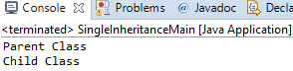

// Program using Multilevel Inheritance

**package** com.java;

**public** **class** MultipleInheritanceA {

**void** displayA()

{

System.***out***.println("Parent class");

}

}

**package** com.java;

**public** **class** MultipleInheritanceB **extends** MultipleInheritanceA {

**void** displayB()

{

System.***out***.println("Sub classB, which inherits Parent classA");

}

}

**package** com.java;

**public** **class** MultipleInheritanceC **extends** MultipleInheritanceB{

**void** displayC()

{

System.***out***.println("Sub classC, which inherits properties of Parent classA and Sub classB");

}

}

**package** com.java;

**public** **class** MultipleInheritanceMain {

**public** **static** **void** main(String args[])

{

MultipleInheritanceC ob = **new** MultipleInheritanceC();

ob.displayA();

ob.displayB();

ob.displayC();

}

}

OUTPUT:

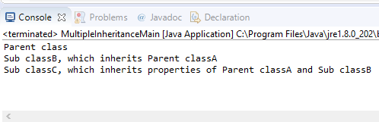

// Program using Hierarchical Inheritance

**package** com.java;

**public** **class** HierInheritanceA {

**void** displayA()

{

System.***out***.println("Parent class, which is inherited by sub classes");

}

}

**package** com.java;

**public** **class** HierInheitanceB **extends** HierInheritanceA{

**void** displayB()

{

System.***out***.println("Sub classB, which inherits Parent classA");

}

}

**package** com.java;

**public** **class** HierInheritanceC **extends** HierInheritanceA{

**void** displayC()

{

System.***out***.println("Sub classC, which inherits Parent classA");

}

}

**package** com.java;

**public** **class** HierInheritanceMain {

**public** **static** **void** main(String args[])

{

HierInheritanceC ob = **new** HierInheritanceC();

ob.displayA();

ob.displayC();

}

}

**OUTPUT:**

